NAMA : a). DEA DIANA SARI (242310045)

b). SAJIDAH PERWIN (242310044)

1.

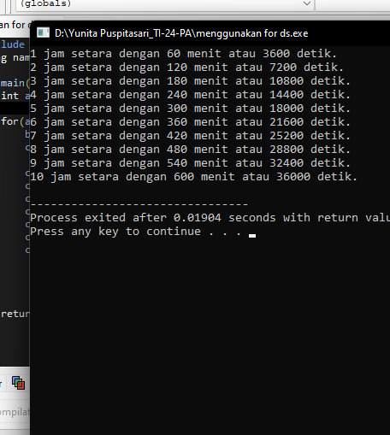

#include <iostream>

using namespace std;

int main(){

int a,b,c;

for(a=1; a<=10; a++){

b=a*60;

c=a*3600;

cout<<a ;

cout<<" jam setara dengan ";

cout<<b;

cout<<" menit atau ";

cout<<c;

cout<<" detik.";

cout<<endl;

}

return 0;

}

2. #include <iostream>

using namespace std;

int main()

{

int a=242310044,b=242310045,c,npm1,npm2;

cout <<"Masukan npm pertama :";

cin >> npm1;

cout <<"Masukan npm kedua :";

cin >>npm2;

if (a== npm1 && b== npm2){

cout <<"\nMasukan jumlah deret :";

cin >>c;

int d=0,e=1,f;

cout <<"Deret Fibonacci : \n"<< d << " " << e << " ";

for (int i=2; i<c; i++){

f=d+e;

d=e;

e=f;

cout << f << " ";

}

}

return 0;

}

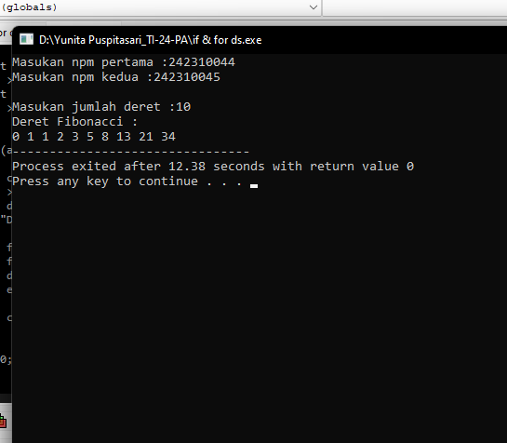

3.

|  |  |
| --- | --- |
| i | J |
| 1 | 1 |
| 1 | 2 |
| 1 | 3 |
| 1 | 4 |
| 2 | 1 |
| 2 | 2 |
| 2 | 3 |
| 2 | 4 |
| 3 | 1 |
| 3 | 2 |
| 3 | 3 |
| 3 | 4 |
| 4 | 1 |
| 4 | 2 |
| 4 | 3 |
| 4 | 4 |

Cout J

1234

1234

1234

1234